Printing Hello world

Workshop #1

Flutter Developer Bootcamp

# **Purpose**

This workshop demonstrates likely to introduce participants to the Dart programming language, focusing on its syntax, basic operations, and running simple programs.

**Problem**

In the given workshop demonstrates a basic "Hello, World!" program. It starts with the main function, defined as void main(List<String> args), which serves as the entry point of the application and can optionally accept command-line arguments. Inside the main function, print('Hello world'); outputs the string to the console. This simple example introduces Dart's basic syntax and structure, showcasing function definition, potential command-line input handling, and console output. It's an ideal starting point for setting up a Dart development environment and practicing basic Dart programming.

**How to Solve**

1. Checkout the workshop from Git Repo:

git clone -b <user-branch> <repo-URL>

1. Open the root folder inside VS Code
2. Open the root folder in terminal
3. Run the command dart run filename.dart
4. Program Start:

* When the Dart program is executed, the Dart runtime looks for the main function and starts execution from there.

1. Print Statement Execution:

* The print('Hello world'); statement is executed, which outputs the string Hello world to the console.

1. Go To File: <specific-file--method> à <method-name>, implement your logic.

**You will Achieve**

When you complete this workshop you will learn the following:

Methods and Functions Included**:**

* **main Function:**
* Syntax: void main(List<String> args)
* Purpose: Serves as the entry point of the Dart application. It can accept a list of command-line arguments.
* **print Function:**
* Syntax: print(Object object)
* Purpose: Outputs text or objects to the console. In this case, it is used to print the string 'Hello world'.

# **Screenshots**

## **Before implementation (without printing hello world)**

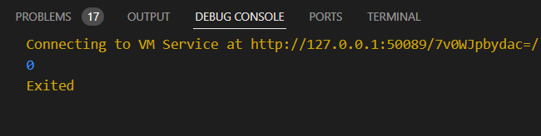

## **After implementation (with printing hello world)**

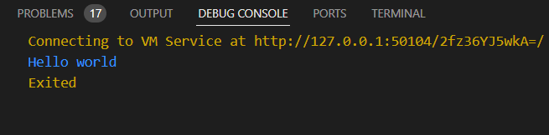

# **How to submit your workshop**

Push your project back to the same git branch using command:

<command name>

# **Happy Coding!**